Online Reviews Highly Correlate with Referral Volume for New Hand Surgeons

Hypothesis: No direct correlation has yet been proven between online physician ratings and patient referral volume. Rather, the recent emphasis on optimizing a physician’s online reputation is based on the assumption that enhanced online ratings translate into patient volume and revenue. This study sought to correlate online rating volume and scores with volume of new patient referrals.
Methods: This prospective study recorded online physician ratings from Yelp and Healthgrades, as well as practice ratings from Yelp and Google, during a 42 month period (14 quarters). We simultaneously tracked self-reported referral sources for all new patients, with special attention paid to those referred by online search and review sites. We then correlated the volume of online reviews with new patient referrals for the practice as a whole, a new hand surgeon (fellowship graduate), and an established hand surgeon (25 years in practice).
Results: During the 3.5-year study period, the new surgeon acquired 204 reviews and 174 online patient referrals with an average score of 4.9 stars. The established surgeon acquired 48 reviews and 117 online patient referrals with an average score of 4.3 stars. The practice as a whole acquired 381 reviews and 387 online patient referrals with an average score of 4.8 stars. The correlation between reviews and referrals on a quarterly basis are shown in Figure 1, and reflect a very high correlation (R^2 = 0.917) for a new surgeon, but non-correlated (R^2=0.07) for an established surgeon. The correlation between referrals and reviews for the practice as a whole was moderate, with R^2=0.56 (Figure 2).
Summary Points:
- Patient referrals are directly and highly correlated with online physician ratings (R^2=0.92) for new hand surgeons
- No apparent correlation was identified for established hand surgeons (25+ years in practice)
- Online reviews have the potential to augment practice growth primarily for new hand surgeons

Figure 1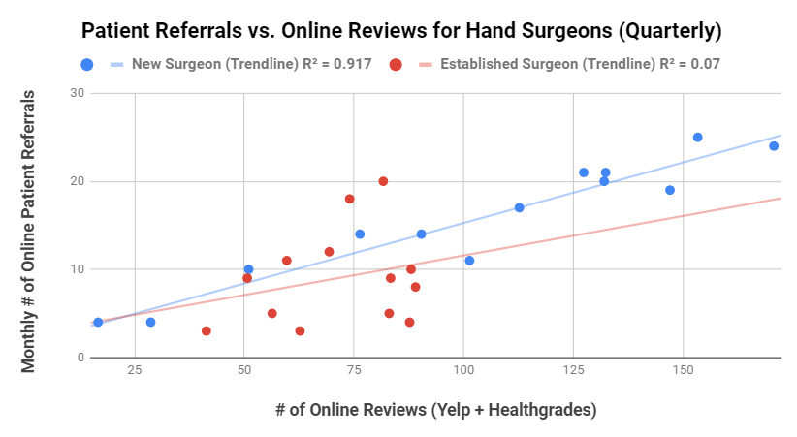
Figure 2