Solving the Chicken vs. Egg Question: Does Website Traffic Drive New Patient Visits?

Hypothesis: Practice websites are a valuable component of hand surgery practices by providing contact information, sharing patient education materials, and helping drive patients to the practice. Monitoring website traffic is therefore a simple and useful tool for gauging a site’s success. However, an upward trend in website traffic could have numerous explanations, ranging from overall practice growth to a more internet-savvy patient population. The hypothesis of this study was that increased website organic search primarily correlates with new patient visits.

Methodology: This prospective study collected website analytics from a hand surgery practice for 3.5 years with a focus on organic search. In addition, patient office visit data was collected monthly according to visit type: new patient, former patient, follow-up visit, and total office visits. A scatter plot with a best-fit regression line was drawn for each visit type as it correlates to website traffic to determine the primary influencing factor contributing to website traffic growth. R^2 values were calculated to determine best fit line.

Results: During the 3.5 year study period, website traffic increased 4-fold with organic search results averaging 138 impressions in the first three months and 531 impressions at the final 3 months (Figure 1). During that same period total patient visits increased from 326 patients/month to 499 patients/month (Figure 1). The plot results for new, former, follow-up, and total patient visits with regression lines are shown in Figure 2. The regression analysis demonstrated the highest correlation with new patients (R^2=0.50), despite the fact that follow-up visits were of higher volume. These findings suggest that new patients most closely correlate with website traffic over former or follow-up patient visits.
Summary Points:
- Practice websites can be a useful tool for attracting new patients
- Website organic search impressions most closely correlate with new patient visits and not former or follow-up patient visits
- Improving practice website traffic can increase patient volume

Figure 1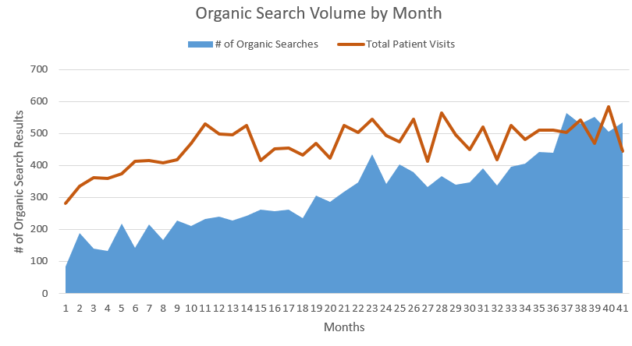Figure 2